**DAILY ONLINE ACTIVITIES SUMMARY**

|  |  |  |  |  |  |  |  |
| --- | --- | --- | --- | --- | --- | --- | --- |
| **Date:** | **12/06/2020** | | | | **Name:** | **Imran Khan** | |
| **Sem & Sec** | **8th A** | | | | **USN:** | **4AL16CS040** | |
| **Online Test Summary** | | | | | | | |
| **Subject** | | **BDA** | | | | | |
| **Max. Marks** | | **30** | | **Score** | | **20** | |
| **Certification Course Summary** | | | | | | | |
| **Course** | **HTML,JAVASCRIPT&BOOSTRAP** | | | | | | |
| **Certificate Provider** | | | **UDEMY** | **Duration** | | | **6 HOURS** |
| **Coding Challenges** | | | | | | | |
| Problem Statement:  Write a C Program to split the resultant array.. | | | | | | | |
| **Status: Solved** | | | | | | | |
| **Uploaded the report in Github** | | | | **yes** | | | |
| **If yes Repository name** | | | | **Imran040** | | | |
| **Uploaded the report in slack** | | | | **yes** | | | |

Online test details:

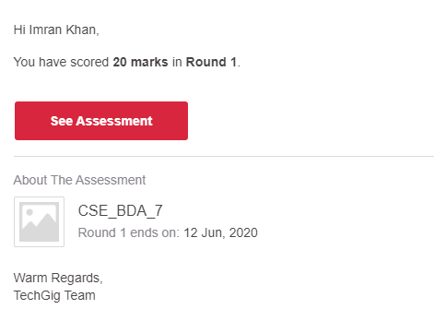

**Certification Course Details**:

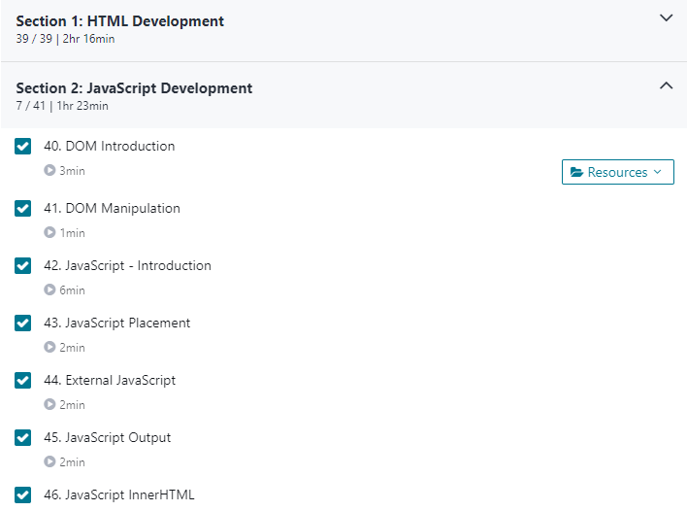

**Coding Challenges Details**:

**program1:**

|  |  |  |  |
| --- | --- | --- | --- |
|  | | | |
|  | |
| #include <stdio.h> | |
|  | | void main () |
|  | | { |
|  | |  |
|  | | int number[30]; |
|  | | int i, n, a, j; |
|  | |  |
|  | | printf("Enter the value of n\n"); |
|  | | scanf("%d", &n); |
|  | |  |
|  | | printf("enter the numbers\n"); |
|  | | for (i = 0; i < n; ++i) |
|  | | scanf("%d", &number[i]); |
|  | |  |
|  | | printf("Enter the position of the element to split the array \n"); |
|  | | scanf("%d", &a); |
|  | |  |
|  | | for (i = 0; i < a; ++i) |
|  | | { |
|  | |  |
|  | | number[n] = number[0]; |
|  | | for (j = 0; j < n; ++j) |
|  | | { |
|  | | number[j] = number[j + 1]; |
|  | | } |
|  | |  |
|  | | } |
|  | |  |
|  | | printf("The resultant array is\n"); |
|  | |  |
|  | | for (i = 0; i < n; ++i) |
|  | | { |
|  | | printf("%d\n", number[i]); |
|  | | } |
|  | |  |
|  | | } |